(Approx. 632 words)

Website Analytics
Author: Jeff Wilkinson, President
Sun City Summerlin Computer Club, NV
September 2019 issue, Gigabyte Gazette
www.scscc.club
pres.scscc (at) gmail.com

Data gathered from website logs can provide a vast amount of data about how users interact with a website. Examples include the entry points of each user, which give an indication of how the website was found, to the exit pages, which give an indication of the effectiveness of your website. Using this valuable data allows optimization of a website to achieve its stated goal.

Google Analytics, which is part of any Gmail account, offers many insights into website visitor behavior. By inserting a small bit of code on a website, you can begin to gather basic data. The data can be further refined by setting various goals, such as subscribing to a newsletter or viewing an announcement page.

With Google Analytics you can view behavior patterns of your visitors and use the information to fine tune your website. While the expected progression or path through a website may be perfectly clear to the web designer, observing the data can reveal entirely different behavior. A website has a specific purpose when created and it just makes sense to be able to measure the progress towards that goal. An ecommerce website has specific goals and wants clear intuitive paths through the website to those goals. With analytic data, pages can be fine-tuned to help guide the user and make a purchase decision easier.

Analytics allow collection of data over time based on a myriad of parameters. For instance, you can tell which page visitors to a website entered the site and which page they exited, how long they stayed on each page and what page they went to next. If visitors landed on a page and immediately exited your website that could indicate an issue with that page, but if they landed on a page and immediately went to another page within you site to complete a call to action that would be important data to have. You could then experiment with different words and phrases and measure their effectiveness in guiding users to a desired web page.

If you have ever purchased items online, you have certainly noticed how some sites make it extremely simple to purchase while other are not so easy. Amazon.com is a good example of a finely tuned website that makes shopping and completing a purchase very easy. This is the result of constant attention to the feedback provided by analytic data and modifying pages to make a purchase as easy as possible.

I recently was researching a Samsung Blue Ray player I own and searched on the part number in both Google shopping and eBay. The next day I began receiving email marketing material for various products with portions of the part number I was searching for! How did they know? - analytics.
United Parcel Service has developed their own in-house analytical software to use the data gathered from multiple inputs to refine routing and delivery times. Analytic data is an important aspect of the parcel delivery business and a factor in profitable yet competitive pricing.

Gathering and interpreting analytic data can be a daunting task with overwhelming amounts of data that can easily be misunderstood, or it can be an extremely useful tool in examining the effectiveness of a website. Taken in small steps the insights revealed are very valuable.

Here are some examples of information that Google Analytics can capture and display.
Google Analytics Website Entry Report:
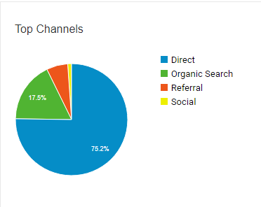
This shows a snapshot in time where there were 9 users on the site. The graph below shows users over time
75.2% of site visitors used the URL to access the page directly, but 17.5% had to search to find your page!

Google Analytics Active Users Report:
